Natural Language Processing



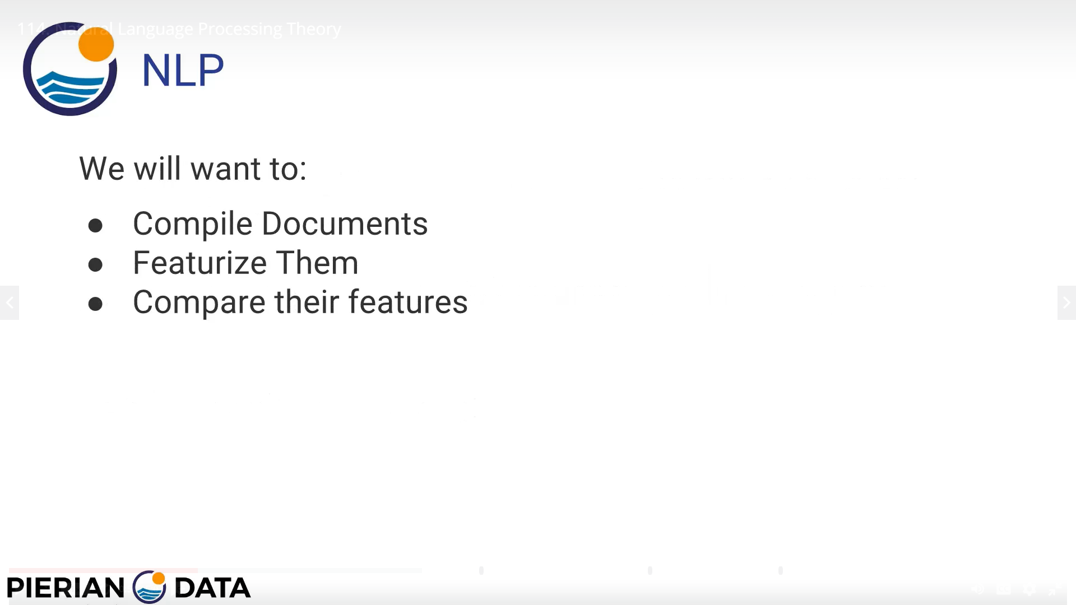

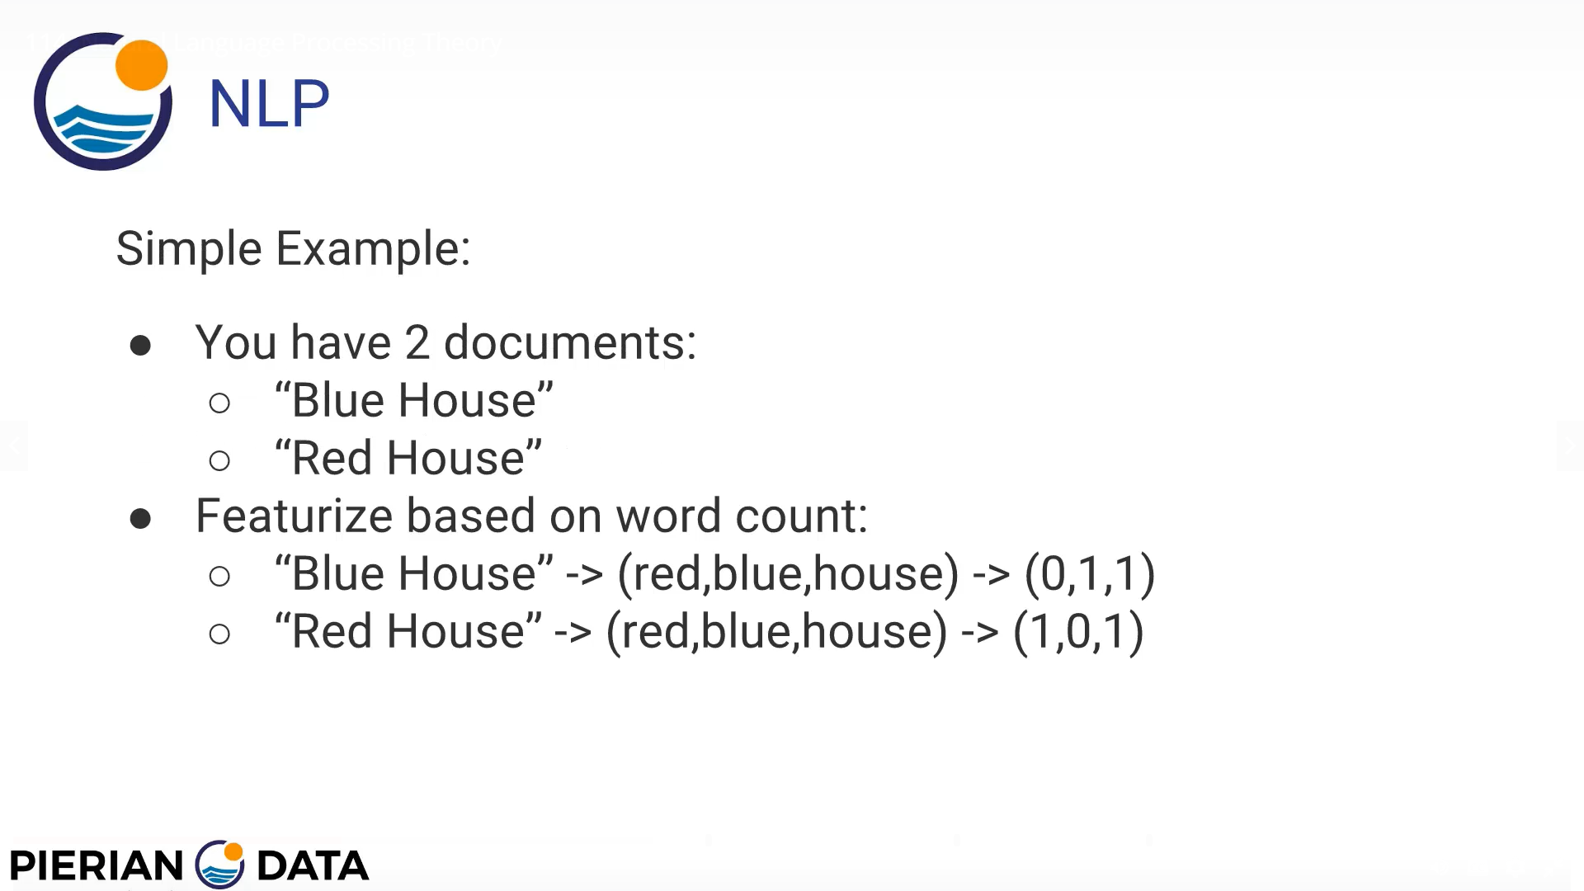

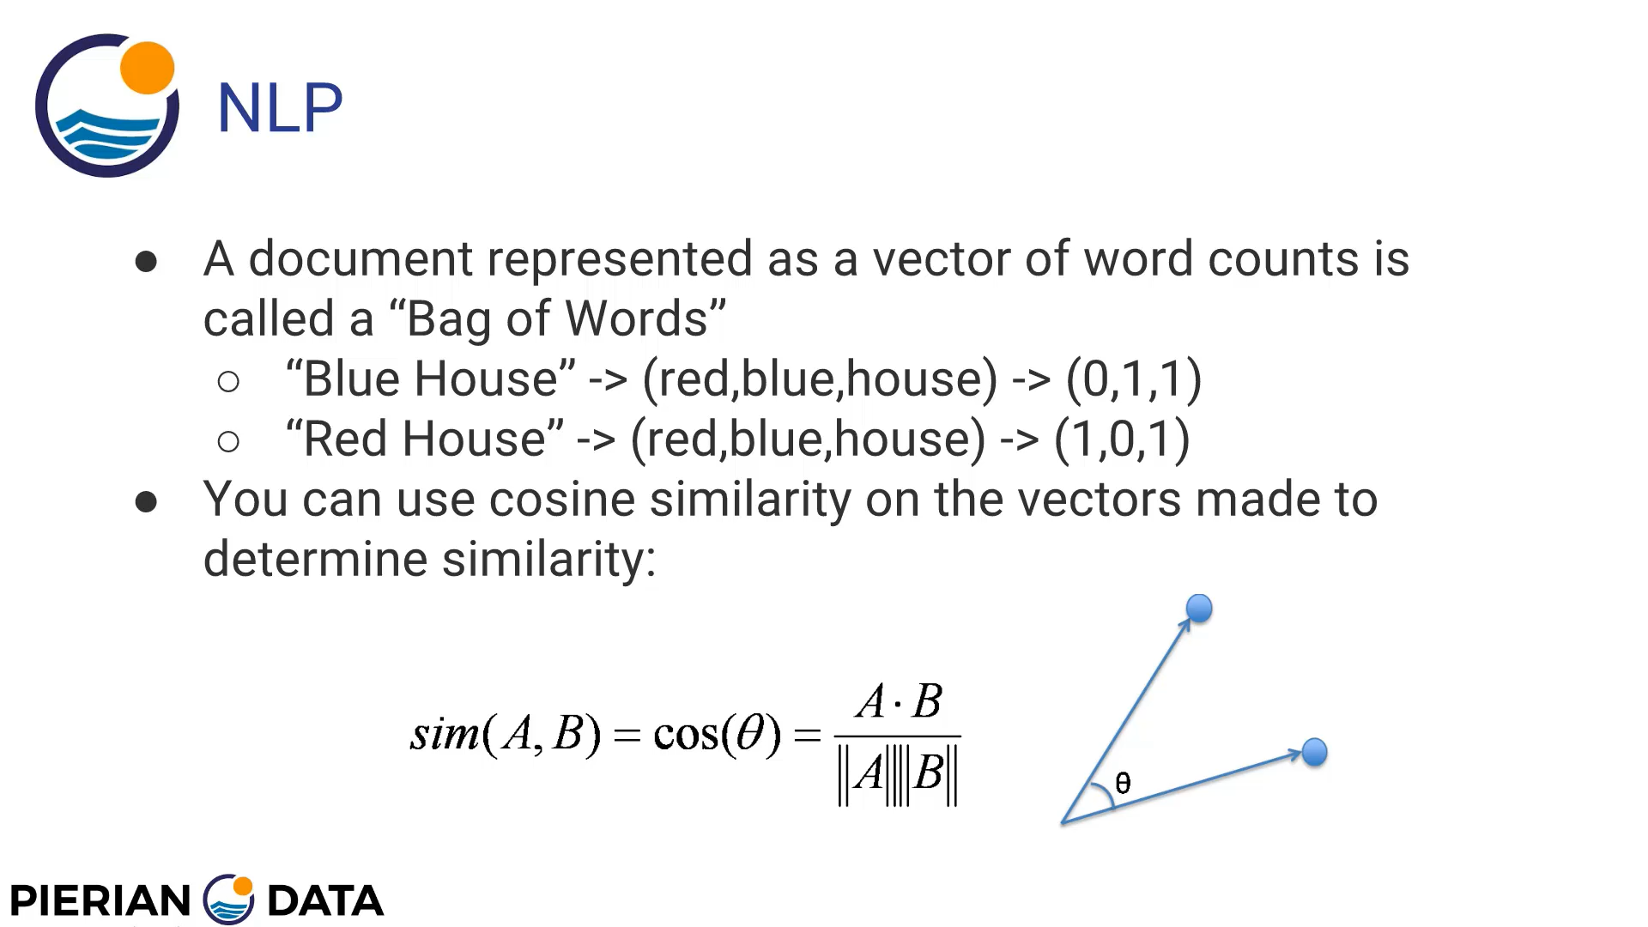

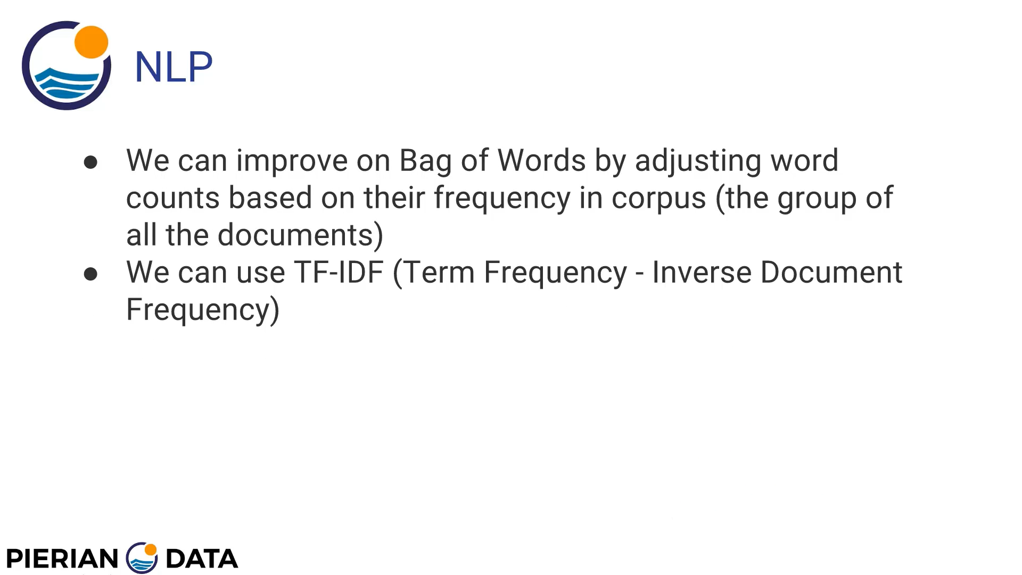

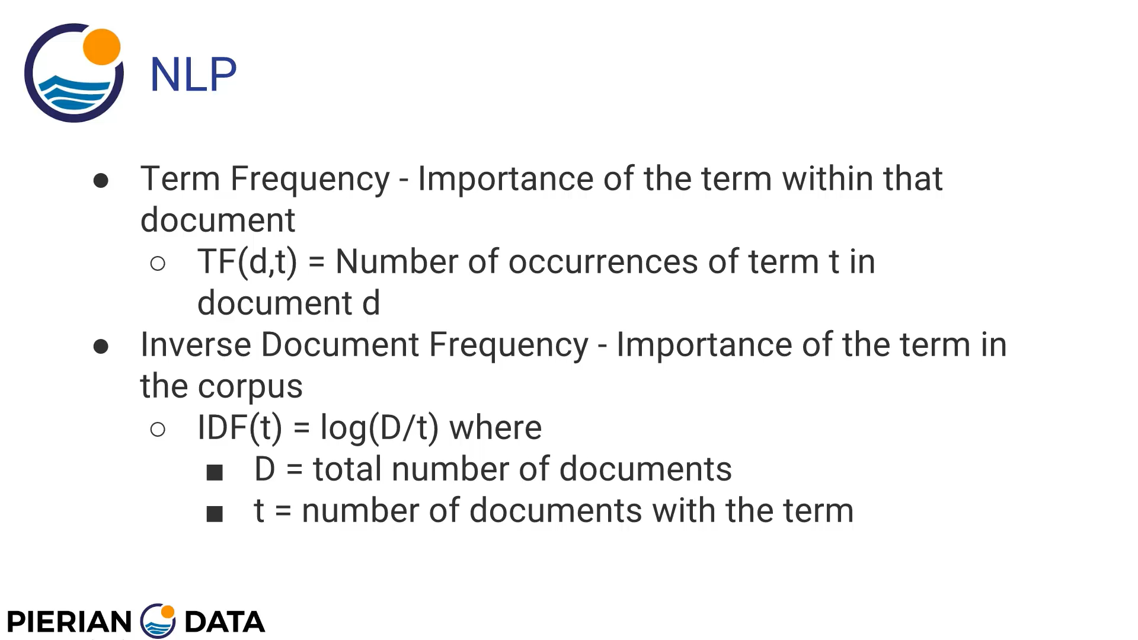

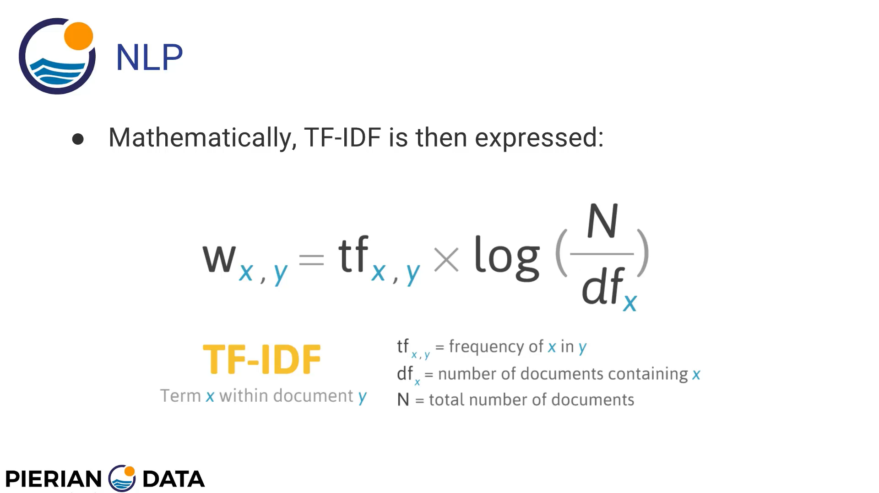

# Downloading required packages from nltk

import nltk  
  
nltk.download_shell()

we will not comment this download_shell() command and continue with our code after downloading stopwords corpus data package.

# Importing data from our data file and getting a view of it

import nltk  
  
#nltk.download_shell()  
  
messages = [line.rstrip() for line in open("E:/Py-DS-ML-Bootcamp-master/Refactored_Py_DS_ML_Bootcamp-master/20-Natural-Language-Processing/smsspamcollection/SMSSpamCollection")]  
print(len(messages))  
for mess_no,mess in enumerate(messages[:10]):  
 print(str(mess_no) + " " + mess)

# Creating data frame of our data

messages = pd.read_csv("E:/Py-DS-ML-Bootcamp-master/Refactored_Py_DS_ML_Bootcamp-master/20-Natural-Language-Processing/smsspamcollection/SMSSpamCollection",sep="\t",names=["label","message"])  
print(messages.head())

# Performing statistical check of data

print(messages.describe())  
print()  
  
print(messages.groupby("label").describe())  
print()

# Creating a length column to store length of message

messages["length"] = messages["message"].apply(len)  
print(messages.head())  
print()

# Doing some data visualisation with length of message

import seaborn as sns  
import matplotlib.pyplot as plt  
  
messages["length"].hist(bins=150)  
print(messages["length"].describe())  
print()  
messages.hist(column="length",by="label",bins=70,figsize=(12,4))

# Pre-processing data

def text_process(mess):  
 *"""  
 1. remove punc  
 2. remove stop words* ***:param*** *mess: string* ***:return****: return list of clean text words  
 """* nopunc = [char for char in mess if char not in string.punctuation]  
 nopunc = "".join(nopunc)  
 return [word for word in nopunc.split() if word.lower() not in stopwords.words("english")]

# Converting raw sentences into bag of words

import string  
  
from nltk.corpus import stopwords  
print(stopwords.words("english"))  
print()  
  
# Tokenization and defining word vectors  
from sklearn.feature_extraction.text import CountVectorizer  
bow_transformer = CountVectorizer(analyzer=text_process).fit(messages["message"])  
print(len(bow_transformer.vocabulary_))  
print()  
  
# Taking one message and checking its word vector  
mess4 = messages["message"][3]  
bow4 = bow_transformer.tranforms(mess4)  
print(bow4)  
print(bow4.shape)  
print()

# Getting a particular word from bag of words  
print(bow_transformer.get_feature_names()[4068])

# Transforming messages data frame into bag of words vectorisation  
messages_bow = bow_transformer.transform(messages["message"])  
print("Shape of Sparse Matrix : " + str(messages_bow.shape))  
print("Non zero values : " + str(messages_bow.nnz))  
sparsity = ((messages_bow.nnz/(messages_bow.shape[0]*messages_bow.shape[1]))*100)  
print("Sparsity : " + str(sparsity))

# Calculating TF-IDF

# Calculating tf-idf using scikit transformers  
from sklearn.feature_extraction.text import TfidfTransformer  
tfidf_transformer = TfidfTransformer().fit(messages_bow)  
  
# Checking tf-idf of bow4 message  
tfidf4 = tfidf_transformer.transform(bow4)  
print(tfidf4)  
print()  
  
# We can also check idf of a particular word as  
print(tfidf_transformer.idf_[bow_transformer.vocabulary_["university"]])  
print()  
  
# Converting our whole bag of words corpus into tf-idf  
messages_tfidf = tfidf_transformer.transform(messages_bow)

# Using Naïve Bayes Classifier to predict spam

# Using Naive-Bayes Classifier to classify spam and ham messages  
from sklearn.naive_bayes import MultinomialNB  
spam_detect_model = MultinomialNB().fit(messages_tfidf,messages["label"])  
all_prediction = spam_detect_model.predict(messages_tfidf)  
print(all_prediction)  
print()  
  
# Checking prediction on single message  
print(spam_detect_model.predict(tfidf4)[0])  
print()

# Doing train-test split

# Splitting data into training and testing data  
from sklearn.model_selection import train_test_split  
msg_train,msg_test,label_train,label_test = train_test_split(messages["message"],messages["label"],test_size=0.3)

# Creating a scikit pipeline so as not to repeat all the process again

# Creating pipeline of transforms  
from sklearn.pipeline import Pipeline  
pipeline = Pipeline([  
 ("bow_step",CountVectorizer(analyzer=text_process)),  
 ("tfidf_step",TfidfTransformer()),  
 ("classifier_step",MultinomialNB())  
])# our step name can be anything  
pipeline.fit(msg_train,label_train)  
predictions = pipeline.predict(msg_test)

# Printing classification report

# Calculating classification report  
from sklearn.metrics import classification_report  
print(classification_report(label_test,predictions))

# Complete Code –

def text_process(mess):  
 *"""  
 1. remove punc  
 2. remove stop words* ***:param*** *mess: string* ***:return****: return list of clean text words  
 """* nopunc = [char for char in mess if char not in string.punctuation]  
 nopunc = "".join(nopunc)  
 return [word for word in nopunc.split() if word.lower() not in stopwords.words("english")]  
  
import nltk  
import pandas as pd  
  
#nltk.download_shell()  
  
# messages = [line.rstrip() for line in open("E:/Py-DS-ML-Bootcamp-master/Refactored_Py_DS_ML_Bootcamp-master/20-Natural-Language-Processing/smsspamcollection/SMSSpamCollection")]  
# print(len(messages))  
# for mess_no,mess in enumerate(messages[:10]):  
# print(str(mess_no) + " " + mess)  
  
messages = pd.read_csv("E:/Py-DS-ML-Bootcamp-master/Refactored_Py_DS_ML_Bootcamp-master/20-Natural-Language-Processing/smsspamcollection/SMSSpamCollection",sep="\t",names=["label","message"])  
print(messages.head())  
print()  
  
print(messages.describe())  
print()  
  
print(messages.groupby("label").describe())  
print()  
  
messages["length"] = messages["message"].apply(len)  
print(messages.head())  
print()  
  
import seaborn as sns  
import matplotlib.pyplot as plt  
  
messages["length"].hist(bins=150)  
print(messages["length"].describe())  
print()  
messages.hist(column="length",by="label",bins=70,figsize=(12,4))  
  
import string  
  
from nltk.corpus import stopwords  
print(stopwords.words("english"))  
print()  
  
# Tokenization and defining word vectors  
from sklearn.feature_extraction.text import CountVectorizer  
bow_transformer = CountVectorizer(analyzer=text_process).fit(messages["message"])  
print(len(bow_transformer.vocabulary_))  
print()  
  
# Taking one message and checking its word vector  
mess4 = messages["message"][3]  
bow4 = bow_transformer.transform([mess4])  
print(bow4)  
print(bow4.shape)  
print()  
  
# Getting a particular word from bag of words  
print(bow_transformer.get_feature_names()[4068])  
  
# Transforming messages data frame into bag of words vectorisation  
messages_bow = bow_transformer.transform(messages["message"])  
print("Shape of Sparse Matrix : " + str(messages_bow.shape))  
print("Non zero values : " + str(messages_bow.nnz))  
sparsity = ((messages_bow.nnz/(messages_bow.shape[0]*messages_bow.shape[1]))*100)  
print("Sparsity : " + str(sparsity))  
print()  
  
# Calculating tf-idf using scikit transformers  
from sklearn.feature_extraction.text import TfidfTransformer  
tfidf_transformer = TfidfTransformer().fit(messages_bow)  
  
# Checking tf-idf of bow4 message  
tfidf4 = tfidf_transformer.transform(bow4)  
print(tfidf4)  
print()  
  
# We can also check idf of a particular word as  
print(tfidf_transformer.idf_[bow_transformer.vocabulary_["university"]])  
print()  
  
# Converting our whole bag of words corpus into tf-idf  
messages_tfidf = tfidf_transformer.transform(messages_bow)  
  
  
# Using Naive-Bayes Classifier to classify spam and ham messages  
from sklearn.naive_bayes import MultinomialNB  
spam_detect_model = MultinomialNB().fit(messages_tfidf,messages["label"])  
all_prediction = spam_detect_model.predict(messages_tfidf)  
print(all_prediction)  
print()  
  
# Checking prediction on single message  
print(spam_detect_model.predict(tfidf4)[0])  
print()  
  
# Splitting data into training and testing data  
from sklearn.model_selection import train_test_split  
msg_train,msg_test,label_train,label_test = train_test_split(messages["message"],messages["label"],test_size=0.3)  
  
  
# Creating pipeline of transforms  
from sklearn.pipeline import Pipeline  
pipeline = Pipeline([  
 ("bow_step",CountVectorizer(analyzer=text_process)),  
 ("tfidf_step",TfidfTransformer()),  
 ("classifier_step",MultinomialNB())  
])# our step name can be anything  
pipeline.fit(msg_train,label_train)  
predictions = pipeline.predict(msg_test)  
  
# Calculating classification report  
from sklearn.metrics import classification_report  
print(classification_report(label_test,predictions))  
  
plt.show()